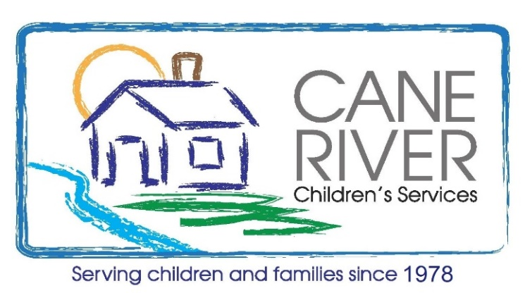
How can YOU Help Stop Child Abuse and Domestic Violence??
Show BIG LOVE by supporting this Charity Shoot to help child victims of crime in Natchitoches!

Saturday, August 26th 2023
Natchitoches Shooting Range- BIG LOVE Charity Shoot- Sporting Clay Event
caneriverchildren.org
Event Information
4-Person Team-- $400.00
Individual Shooter--$100.00

Event Registration – 8:00 AM Register for your spot early to be eligible for prize drawings!!
Shooting Begins – 8:30 AM Make donations payable to Cane River Children’s Services
Lunch Provided
Shells. Lead only. Size 7.5, 8, or 9
12 gauge or 20 gauge

ATV or golf carts okay for Shooting Range path. No 4-wheelers.

Contacts: Nolton Causey—318-663-4964
Lennie Shankle—318-471-3054
Billy Ebarb—318-451-0747
Vicki Parrish—318-352-5866

CANE RIVER CHILDREN’S SERVICES
Did you know that Cane River Children’s Services provides homes for children who have suffered abuse, an transitional living program for older foster youth to learn how to live on their own, a counseling center, and a Child Advocacy Program to prevent child abuse and domestic violence in our community? Federal funding has been severely cut for the Child Advocacy Program. We are in jeopardy of losing community resources for domestic and dating violence, Child Victim Identification Trainings, bullying intervention, and free support services for those victimized by violence!! Check out our website!! See what we do!! We NEED your support!!

VISION STATEMENT
Since 1978, the vision of Cane River Children’s Services is a community of healthy children and families who overcome adversity by connecting to a trauma informed continuum of care and support systems that will ignite a lifetime of healthy change and stop the cycle of abuse.

